OCLC and IEEE have partnered to provide access to your IEEE Publications Database subscription content through WorldCat® Discovery Services, maximizing your subscription value. WorldCat Discovery enables your users to discover more than 1.5 billion electronic, digital and physical resources in libraries around the world through a single search of WorldCat and a central index representing more than 2,000 e-content collections.
The OCLC/IEEE partnership increases your users’ visibility into your IEEE Publications Database subscription content and enables links to IEEE full text through either the WorldCat knowledge base or a knowledge base already in place at your library.
WorldCat Discovery Benefits for IEEE Publications Database Subscribers
- Give your users searchable access to all  - IEEE periodicals  - IEEE conference proceedings  - IEEE online standards  - IEEE Xplore eBooks |  | - Allow users to see relevant items from the IEEE Publications Database in their default search results  - Create a database group to search IEEE Publications Database and databases with related content together  - Coming soon, provide access to the IEEE-Wiley eBooks Library and the MIT Press eBooks Library via IEEE

Next steps
Access your IEEE subscription through WorldCat Discovery!
1. Review your searchable databases.  Go to the OCLC Service Configuration page at worldcat.org/config. Sign in, select Metasearch Content from the left menu, and choose Licensed Content and Databases. | 2. Add the IEEE Publications Database.  Click the add/remove databases button. Simply select the IEEE Publications Database and the subscribed IEEE Book Collections and click Done to allow your users to search the database.
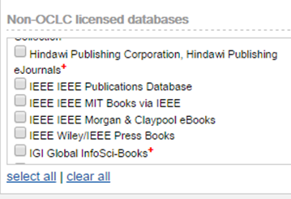
Questions?
Learn more about WorldCat Discovery at http://oc.lc/WorldCatDiscovery. See available content, detailed FAQ, migration resources and upcoming webinar listings. Or contact OCLC Customer Support at support@oclc.org. |  | Contact training@ieee.org with questions about the IEEE Publications Database, accessible through WorldCat Discovery.

